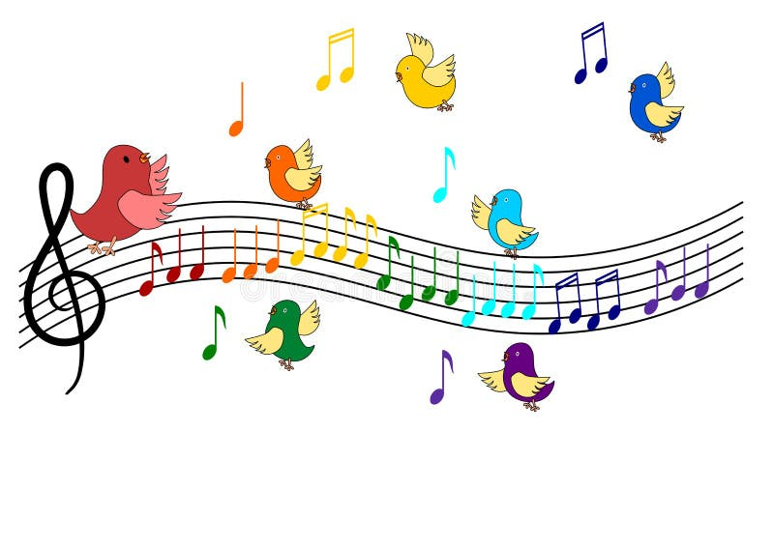





Musicals old and new will make appearances in our summer concert, starring all the hitmakers - Berlin, Bernstein, Rodgers and Hammerstein, Lerner and Lowe, and more. We’ll revel in music from your favorite shows – after enjoying our famous ice cream sundae buffet, of course.

**Sunday, June 29, 2025, Concert 4 pm. Ice cream 3:15 pm.**







A string quartet will set off our holiday concert in style. We plan to feature everything from the sacred (“Silent Night” and “Celebration of Light”) to the secular (“It’s the Most Wonderful Time of the Year”). Enjoy a refreshing moment during this often-hectic time of year.

Birds, weddings, Mardi Gras, flowers – songs through the ages have embraced these perennial Spring themes. Our concert will present them in a sampling of styles, including folk songs, madrigals, classics from masters like Brahms and even a few jazz standards. Come be inspired by the eternal allure of Spring.

**Sunday, March 30, 2025, 4:00 pm**

**Holiday Joy & Strings**

***Sunday, December 15, 2024, 4:00 pm***

Become a Season Subscriber

*The benefits include a discount for season ticket purchase plus the chance to hear three great concerts!*

*___I would like to purchase ______Season Subscription(s) @ $60/subscription*

*= total $ ___________*

*___I would like to make a tax-deductible donation of $ __________*

*(The Concert Singers is a 501(c)3 organization)*

*= total amount $ ____________*

*Please make checks payable to: The Concert Singers, PO Box 90327, Los Angeles CA 90009-0327*

***LOCATION FOR ALL CONCERTS:***

*Covenant Presbyterian Church, 6323 W. 80th Street, Los Angeles CA 90045*

***TICKET PRICES:***

***$25****; (Groups of 8 or more: $20 per person)* ***(suggested donation)***

***FOR THE WINTER CONCERT:*** *Tickets at the door will be* ***$20*** *(suggested donation) if you come with non-perishable food items for Food Pantry LAX.*

**Sing Out Broadway!**

**Celebrating Spring**